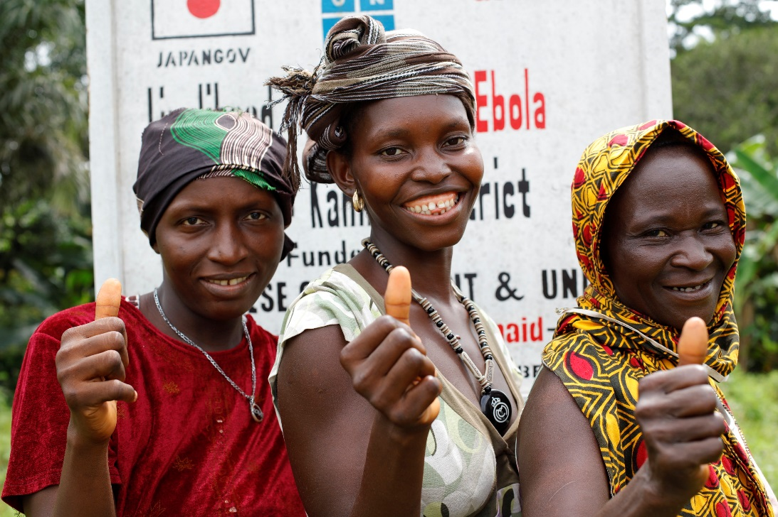
ACTIONAID SIERRA LEONE COUNTRY STRATEGY PAPER III
2018- 2023

Enhancing People’s Action for Social Justice (EPASJ)
(Abridged version)

Introduction
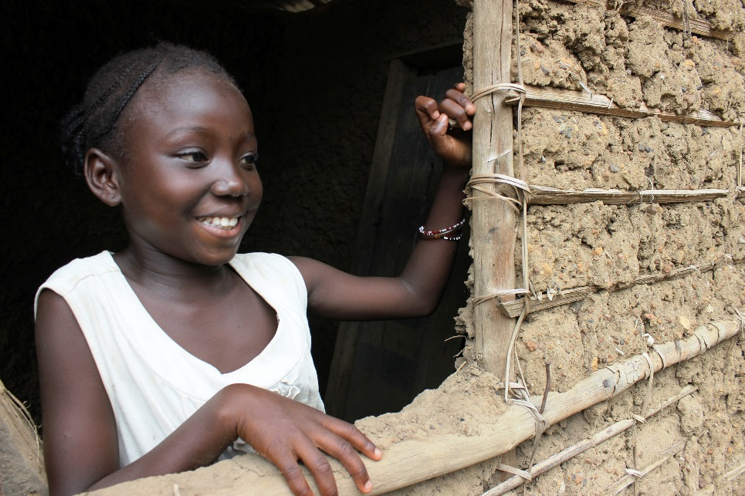
ActionAid has worked in Sierra Leone for slightly over 29 years and has implemented two Country Strategy Papers (CSPs) with thematic focus on Women’s Rights, Land rights, Livelihoods and Education. Owing to the 12-year civil war, ActionAid Sierra Leone was not able to implement the full country strategies, but rather three-year rolling plans (informed by global strategies) which guided its programme implementation up to 2007.
The first country strategy paper, Enhancing Governance and Accountability to end Poverty (EGAP), focused primarily on governance work; the effects of the 12-year civil war between 1991 and 2012, which led to the complete breakdown of governance structures. ActionAid therefore focused on governance as its main thematic area of work during the post conflict recovery period.
The second strategy, Claiming Rights to End Poverty (CREP), which was implemented between 2013- 2017, prioritised work on land rights and livelihood, holding government to account for the provision of basic services and violence against women and girls. During that phase, ActionAid and partners demanded government and other agencies’ accountability through its tax justice and land right campaigns which advanced the organisation’s strategic objective on women’s and girls’ rights. During the implementation of the strategy, there was a dramatic shift from a thematic to a more holistic approach. This move enhanced more integration to address the bigger picture.

Who are we?
ActionAid Sierra Leone is a member of the global federation of ActionAid working to achieve social justice, gender equality and poverty eradication. In our work to we strive to eradicate poverty, taking into cognizance issues around gender equity with regards to access to services.

We have operated in Sierra Leone for over 29 years with strong knowledge of the complexities of poverty due to our rootedness in the communities, our relationship with stakeholders at all levels and the networks and coalitions we have been part of. Our work has been clearly identified with our commitment to put women in the centre of everything we do which gives us the space to build solidarity with social movements and other interest groups to achieve social justice and gender equality. We work in all the five regions (Southern, Northern, North-West, Eastern and Western Area) of the country and in eight districts (Bo, Bombali, Kambia, Kono, Karene, Moyamba, Tonkolili and Western Area), out of 16-administrative districts in Sierra Leone.

Our Vision
A just, equitable and sustainable world in which every person enjoys the right to a life of dignity, freedom from poverty and all forms of oppression.

Our Mission
To achieve social justice, gender equality and poverty eradication by working with people living in poverty and exclusion, their communities, people’s organisations, activists, social movements and supporters.

Our Values
Mutual respect, Equity and Justice,Integrity, Solidarity with People Living in Poverty and Exclusion, Courage of conviction, Independence, Humility

Our Theory of Change
In Sierra Leone culture and traditional beliefs and practices are reinforced by visible, hidden and invisible powers that hinder the full realisation of rights for marginalised groups, especially women, young people and children. Moreover, the 1991 constitution of Sierra Leone still recognises the role of culture and tradition because of the dual legal system, which further makes it difficult to hold the state accountable for the full realisation of human rights for women and young people.
The eradication of poverty and injustice can only be achieved through the attainment of social justice and gender equality led by purposeful individuals and collective action to shift unequal and unjust power relations (visible, hidden and invisible) from the household to community, district and national levels.

Our ways of working
In implementing this strategy, we will work with and through partners, coalitions, networks, self-organised groups and alliances. We will continue to work with partners with whom we share similar goals and objectives based on mutual respect, accountability and responsibility.We will connect our work across Local Rights Programmes and network with social movements where they exist or facilitate their formation.
Our New Stategy.
With our new strategy which we have titled Enhancing People’s Action for Social Justice (EPASJ) we have identified the following programme prirorities:

Programme priorities
Three priority areas have been identified and accepted as the focus for this Country Strategy Paper.

Priority 1: Engage the structural causes of violence against marginalised women & girls and promote the recognition, reduction and redistribution of unpaid care work for economic justice.
Violence against Women and Girls (VAWG) persists in Sierra Leone as a pervasive violation of human rights and a major impediment to achieving gender equity and equality. Evidence (reference) shows that 1 in 3 women has experienced violence, mainly at the hands of a partner or spouse and that violence against women leads to a wide range of physical, mental and sexual health problems, and it affects families and communities. Violence against women also has a significant economic impact and impedes the achievement of the development aspirations. The core marginalized groups AASL will be working with include women and girls in communities whose rights are violated through harmful traditional practices and domestic violence, underage commercial sex workers and women living with HIV and AIDS that face stigma and discrimination. Unpaid work in Sierra Leone often includes care giver work, work undertaken on family farms, or family businesses and/or work in the informal economy.

Focus Area 1: Violence against marginalised women and girls:
The Change we desire?
Over the 6 years of the implementation of this strategy, we hope to Increase confidence and ability of women and girls to resist violence which will enhance the reduction in incidents of gender based violence so as to increase women empowerment to claim their socio-economic and political rights.
Focus Area 2: Unpaid care & decent work:

The Change we desire!

We envisage reduced workload on women/girls to enhance their participation in other productive and income generating activities which will facilitate change in community attitudes, behaviours and practices to recognise, value and share unpaid care work responsibly.

Programme Priority Two

Priority 2: Improve public accountability for the provision of responsive basic public services
Focus Area 1: Women and youth participation in democratic processes strengthened
The Change we desire!
- We hope to see more women and young people in leadership positions, and better legislations and policies embracing women and young people’s aspirations and roles in governance processes; a strong civil society groups, networks, coalitions and movements engaging with and holding government to account that will lead to Increased level of transparent and accountable governance.

Focus Area 2: Public financial accountability improved
The Change we desire?
Within the years of implementation of the strategy, we optimize that public financial processes are transparent and accountable leading to improved allocation and utilisation of resources that benefits the poor. A kind of Government that has the ability to generate revenue to finance public services benefitting the poor which will lead to an Increase in citizens engagement in public finance allocation, utilisation and reporting processes.

Focus Area 3: An effective and efficient Public Service responsive to the needs of people
The Change we desire!
An Improved public service provision in the health, education, water and sanitation sectors that is available, accessible, affordable and safe. Furthermore an Increased budget allocation to public services that benefits especially women, girls and young people. In education we desire increased retention and transition of the girl child in schools, as we implement this strategy we hope to see Citizens participating and influencing natural resource governance which will propel gender responsiveness, public service delivery across all levels.

4.3 Programme Priority Three

Priority 3: Advance responsive humanitarian action prioritising women & girl’s safety, participation, leadership in emergency preparedness, response and prevention.

Focus Area 1: Build Resilience of Women & Young People with robust accountable processes in Disaster Response

The Change we desire!
- We hope to see women in communities taking the lead in Humanitarian Response, Communities strengthened and have the capacity to play active role in local response.

Focus Area 2: Ensure a Community & Women-Led Humanitarian Preparedness

The Change we desire !
An Active community structure as first-time responders, Strong collaborations with women and young people to enable preparedness at all levels. Also women –led community based protection mechanisms exhibited in response plan and actions which will foster a strong district and national Resilience Plans that placed women and young people at the centre of their response..

Commitment & Aspiration
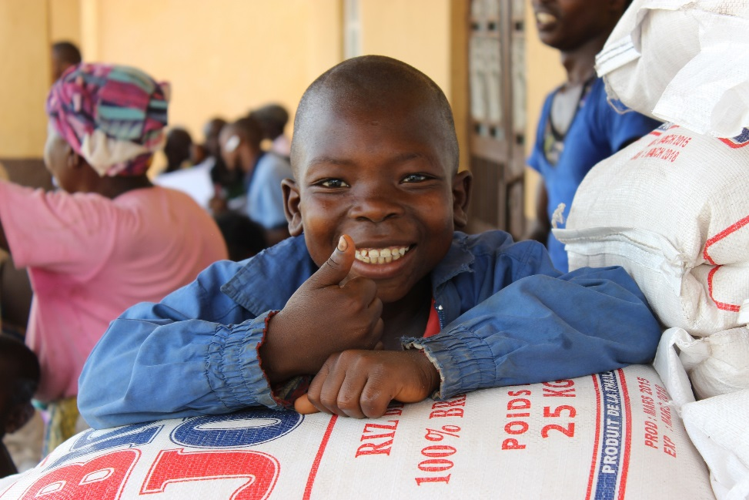
As we set ourselves in enhancing people’e action for soacial change, we are committed in making it right for Women and Girls. Furtehrmore we are focused on building resilient communities where people centred development is the key focus.

Formal and Customary Legal Systems

